**I created a table schema and defined the columns based on the attributes present in a CSV (Comma-Separated Values) file. To populate the table with data, I utilized the "Table Data Import Wizard Option," which is a tool or feature that allows for easy insertion of records from the CSV file into the corresponding table columns. This import wizard simplifies the process by automatically mapping the data from the CSV file to the appropriate columns in the table, ensuring accurate and efficient data insertion.**

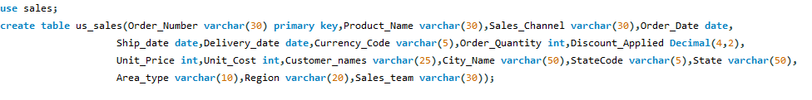

**To validate the accuracy of the data insertion from the CSV file into the table, execute a SELECT statement to retrieve the records. This step ensures that the expected number of records has been correctly imported, confirming data integrity and the successful transfer of data from the CSV file to the table.**

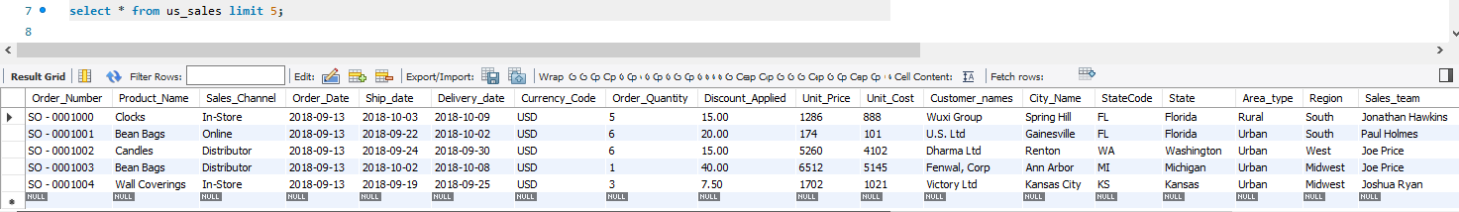

**Feature engineering for adding new columns named "sale_$," "expense_$," and "profit_$" can be accomplished using SQL's ALTER and UPDATE statements. The ALTER statement allows you to modify the structure of a table by adding new columns, while the UPDATE statement enables you to populate those columns with calculated values based on existing data.**

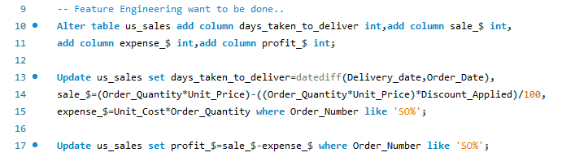



**In a business perspective, the total sales, total expenses, and total profits play crucial roles in data analysis, especially in sales-related scenarios.**

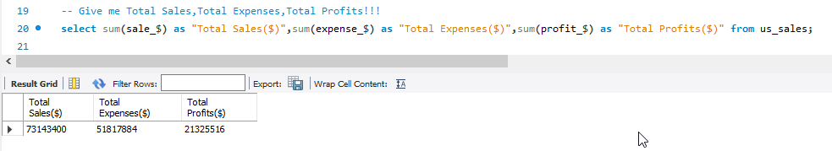

**In a business perspective, the average days taken to deliver products is vital as it directly impacts customer satisfaction, operational efficiency, and reputation.**

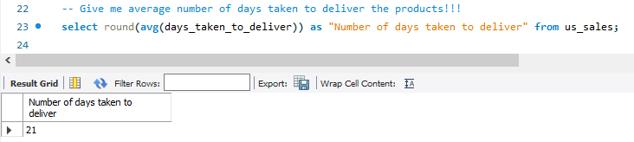

**What are the unique produts have been solded ?**

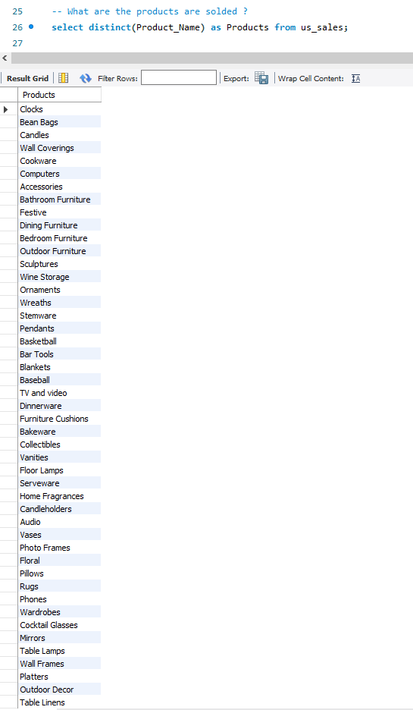

**The total number of products sold provides insights into sales volume and overall business performance, while the number of unique products sold indicates product diversity, market demand, and potential for expanding the customer base. Analysing both metrics helps businesses understand their product portfolio's effectiveness and market reach.**

 

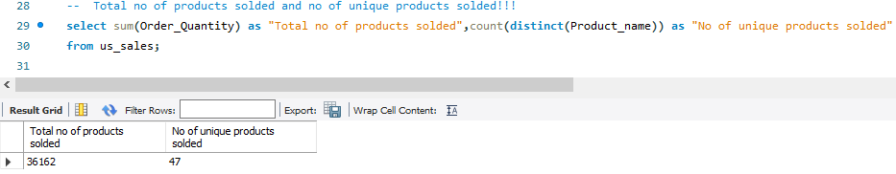

**Sales channels are crucial in sales-based analysis as they reveal how products are reaching customers. Understanding the performance of different sales channels, such as in-store, online, distributor, and wholesale, helps businesses optimize their distribution strategies, allocate resources effectively, and identify opportunities for growth in specific channels based on customer preferences and market trends.**

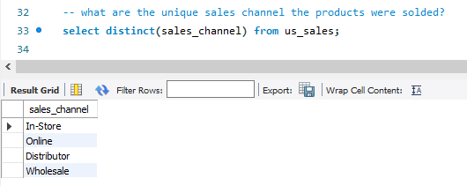

**The number of states and cities where products are sold creates a benchmark for sales analysis by indicating the reach and market penetration of a business.**

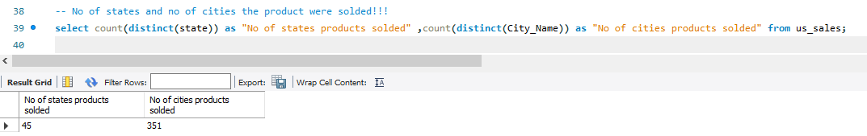

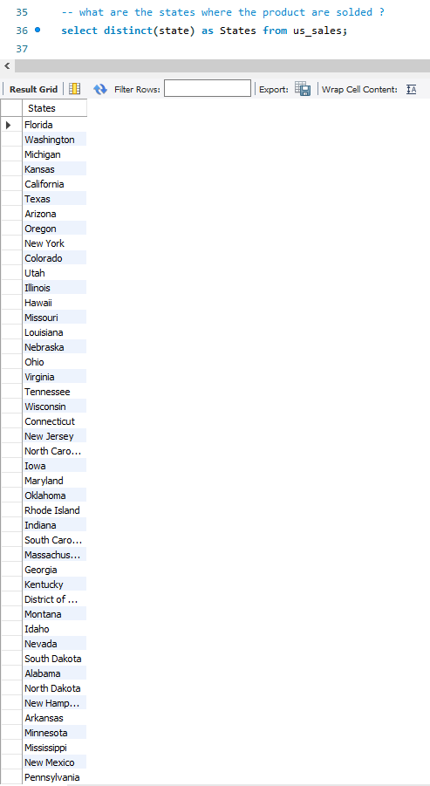

**The number of sales teams involved in product selling is crucial in sales as it impacts sales strategy, performance evaluation, and resource allocation**

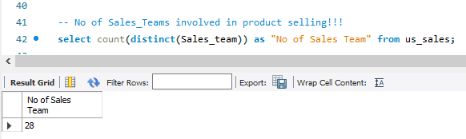

**Analysing the states where products are sold is crucial in sales-based analysis as it provides valuable insights into market presence, regional demand, and expansion opportunities. Understanding the distribution of sales across different states allows businesses to tailor their strategies based on geographic trends and customer preferences.**

** **

**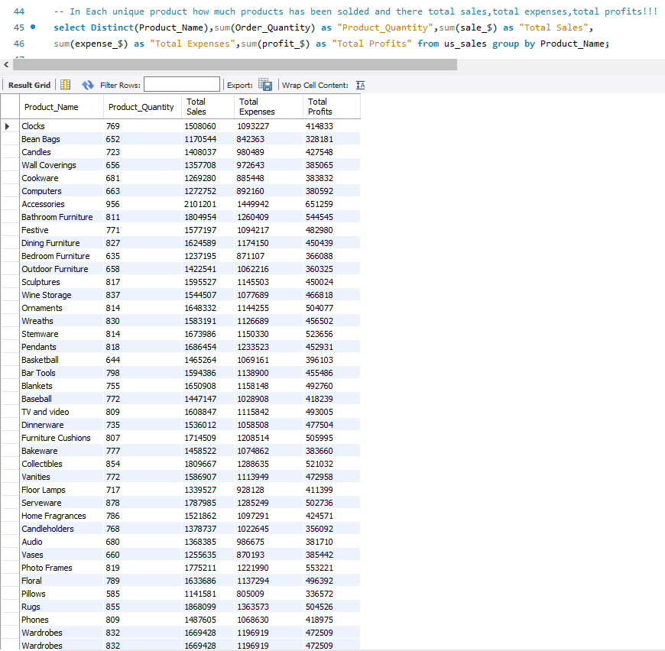  
Analysing the product quantity sold, total sales, total expenses, and total profits by region (South, West, Midwest, Northeast) is essential in sales-based analysis. It provides insights into regional sales performance, revenue generation, and profitability, enabling businesses to identify high-performing regions, allocate resources effectively, and tailor sales strategies based on regional dynamics for maximizing sales and profitability.**

**Listing unique product names along with their total sales, total expenses, and total profits is crucial in sales and business analysis. It provides valuable insights into product performance, profitability, and resource allocation.**

**By analysing this data, businesses can identify their best-selling products, allocate resources effectively, and make informed decisions regarding stock management and inventory replenishment. Moreover, it enables businesses to evaluate the profitability of individual products, optimize pricing strategies, and identify opportunities for cost reduction.**

**In the reality of digital marketing, this information helps in tailoring marketing campaigns, focusing on high-performing products, and maximizing return on investment. Ultimately, leveraging this analysis enhances business profitability, streamlines resource allocation, and drives effective decision-making.**

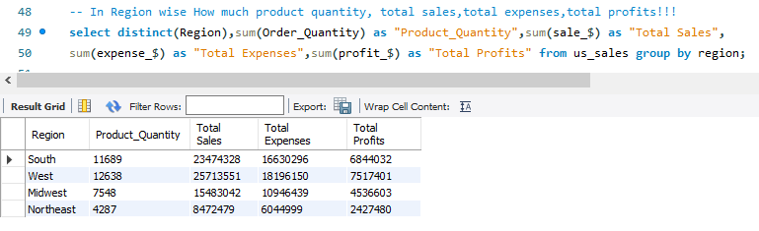

**In sales analysis, it is important to analyse product quantity sold, total sales, total expenses, and total profits based on area types such as rural and urban. This analysis helps businesses understand the sales performance and profitability in different geographic settings.**

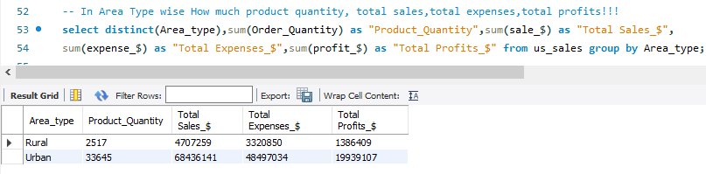

**It is vital to identify the top 5 products with the highest sales and the top 5 products with the least sales is crucial. It allows us to strategize and allocate resources effectively to maximize revenue. For the top-selling products, we can leverage their success by implementing targeted branding strategies that highlight their unique selling points and create a compelling digital presence. For the products with lower sales, we can focus on repositioning, rebranding, or implementing innovative digital marketing tactics to enhance their visibility, address customer pain points, and drive improved sales performance. This proactive approach ensures a well-rounded sales strategy that optimizes revenue potential and strengthens the overall market position.**

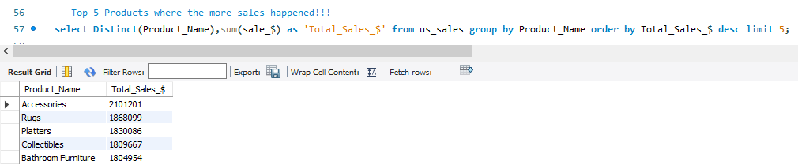

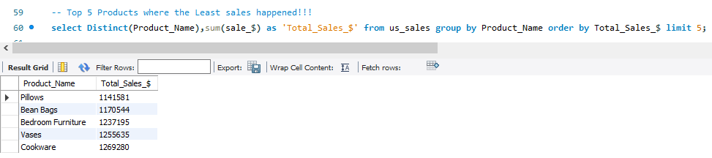

**Certainly! Identifying the top 5 states with the highest sales and the top 5 states with the least sales is essential for sales strategists like us. By recognizing the states where sales thrive, we can focus our resources and marketing efforts on these regions. This strategic approach allows us to tailor our messaging and product offerings to match the preferences and needs of customers in those states, maximizing our chances of success.**

**On the other hand, analysing the states with the least sales helps us pinpoint areas where we can improve. By understanding the factors contributing to lower sales in these regions, we can develop targeted marketing campaigns, adjust pricing strategies, or enhance distribution channels to increase our market share. This approach enables us to uncover untapped potential and drive growth in areas where our sales performance is currently lacking.**

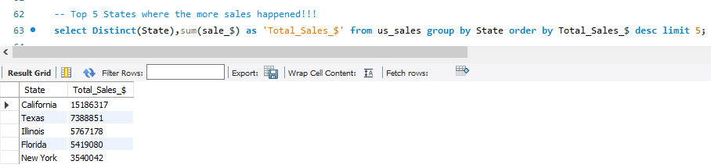

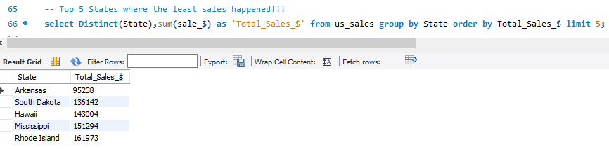

**Identifying the top 5 cities where more sales occur and the top 5 cities with the least sales provides a more granular perspective compared to analysing states. While states give a broader overview, cities allow for a deeper understanding of localized sales patterns.**

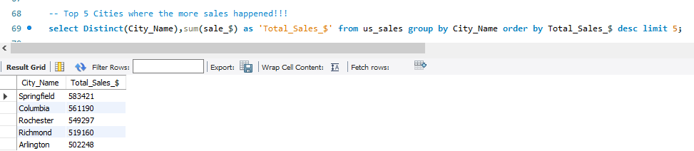

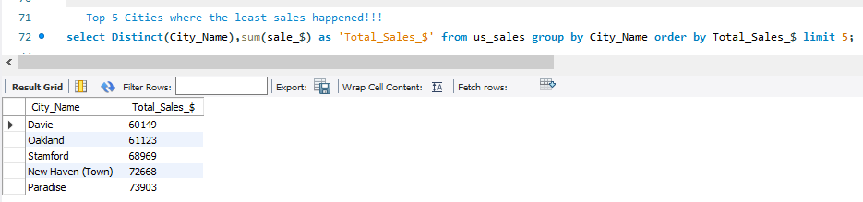

**To leverage the top 5 customers driving higher sales, we prioritize strengthening relationships, enhancing the buying experience, and offering personalized incentives to foster loyalty and repeat purchases. By analysing their preferences, we optimize cross-selling opportunities and tailor marketing campaigns for increased sales growth.**

**For the top 5 customers with lower sales, we implement targeted strategies by analysing their behaviour and providing personalized offers. By understanding their needs, addressing pain points, and engaging them with compelling messaging, we can boost conversion rates and encourage increased purchases.**

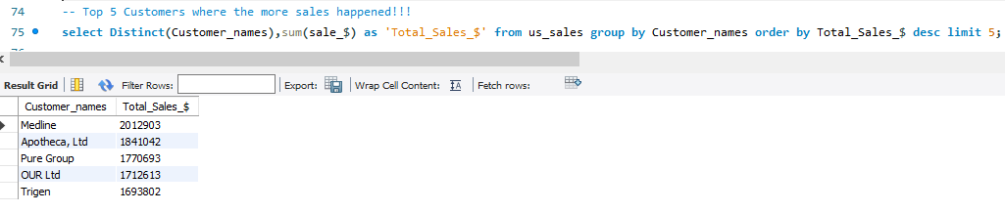

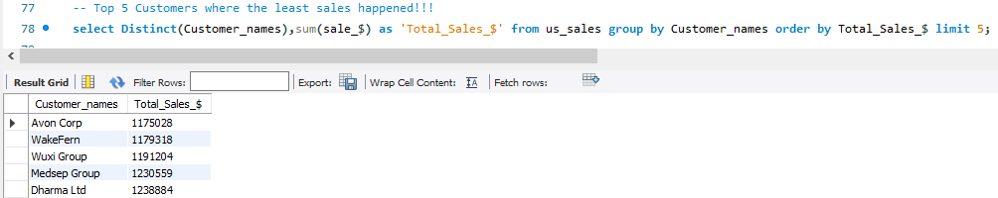

**Recognizing the top 5 sales teams driving more sales and the top 5 sales teams driving less sales is paramount for sales managers, marketers, and CEOs. It serves as a motivation and reward system, inspiring teams to excel and fostering healthy competition. Additionally, it offers invaluable learning opportunities by studying the successful strategies of top-performing teams. Identifying underperforming teams provides a chance for support and improvement through targeted training and resources. Recognizing and respecting all teams cultivates an inclusive work environment, promoting collaboration and collective success. By celebrating achievements and offering guidance, organizations can nurture a culture of growth and continuous improvement. This approach leads to enhanced sales performance and a stronger, more cohesive sales force.**

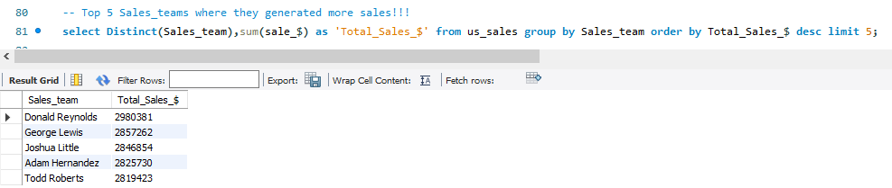

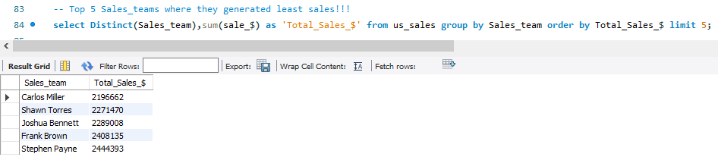

**Regular monitoring of annual sales and profits is essential for strategic planning and maintaining a competitive edge in the market.**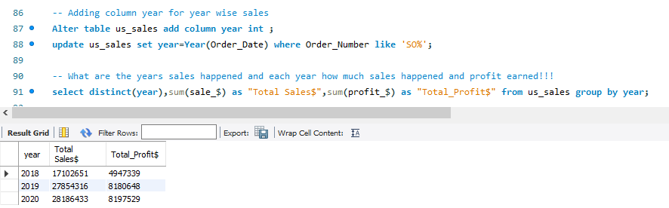

**Calculating the average total sales, expenses, and profits is vital for experts to assess financial performance, optimize costs, and maximize profitability. These metrics provide valuable insights into revenue generation, cost management, and business growth. By analysing averages, experts can make informed decisions to drive sustainable success and enhance overall financial health.**

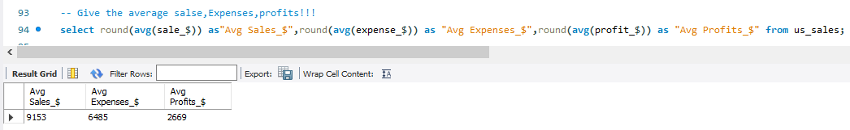

**A customer who places the maximum order quantity is crucial for sales volume and revenue. By nurturing their loyalty, providing excellent service, and understanding their preferences, businesses can drive sustained growth. Furthermore, they can serve as brand advocates, influencing others and attracting new customers through positive word-of-mouth.**

**Although customers who place the minimum order quantity contribute less individually, their collective impact on sales should not be underestimated. Engaging and retaining them through personalized experiences and addressing their needs can lead to increased loyalty, repeat purchases, and valuable feedback for business improvement.**

